Jaunty Coffee Company

**PART B1: Develop SQL code to create each table and provide the code with verification.**

**Employee Table**

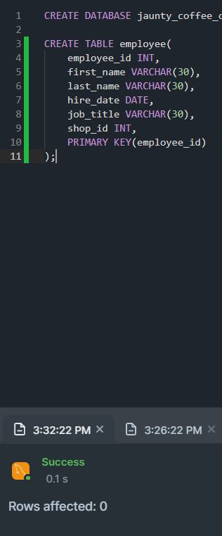

**Coffee Shop Table**

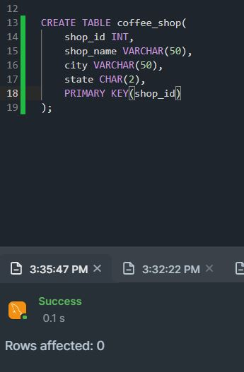

**Coffee Table**

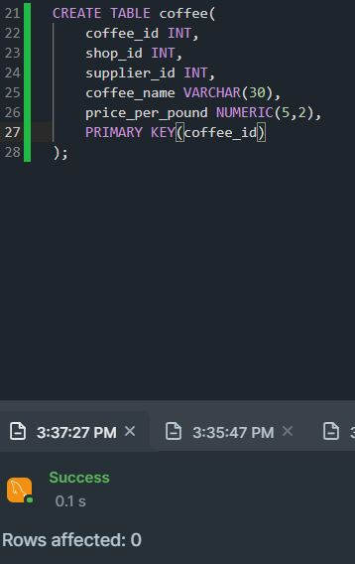

**Supplier Table**

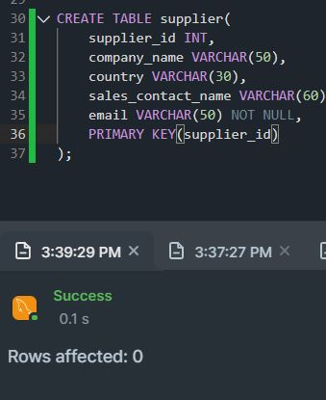

I added the foreign keys after the tables were created.

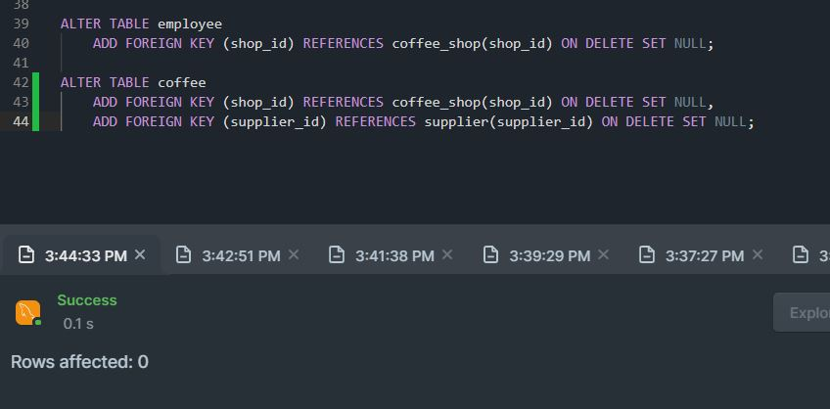

**Database Response**

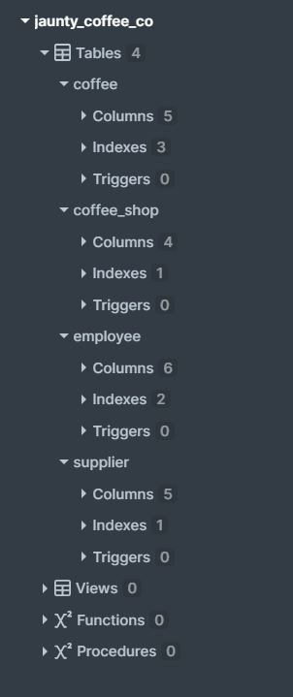

**PART B2: Populating each table with at least three rows of data**

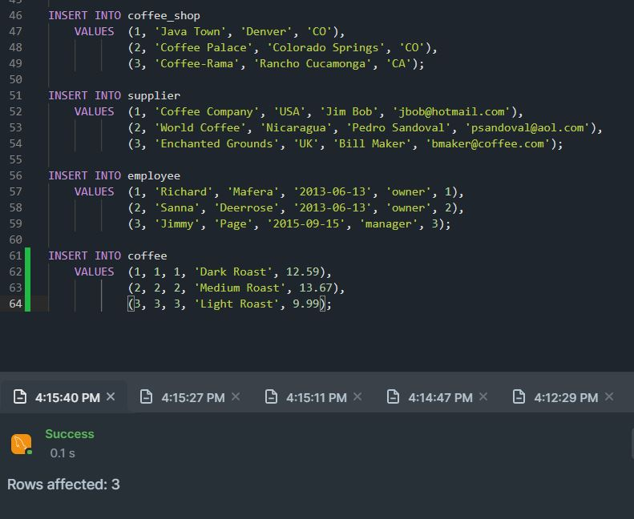

**PART B3: Develop a view with specific information.**

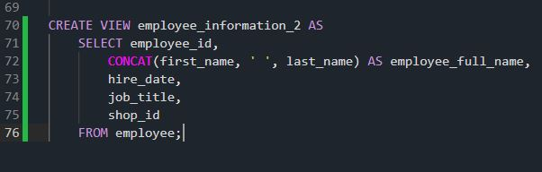

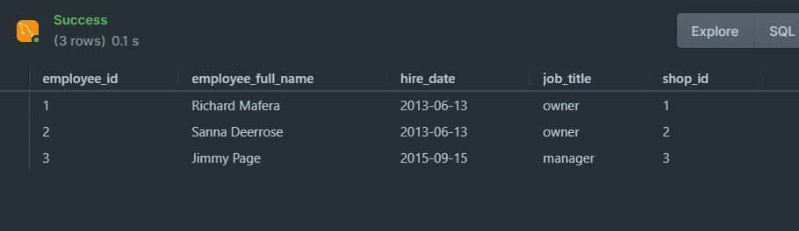

**PART B4: Create an index on the coffee name field.**

**PART B5: Create a SFW query for any of the tables or views.**

**PART B6: Create a join query for three tables.**

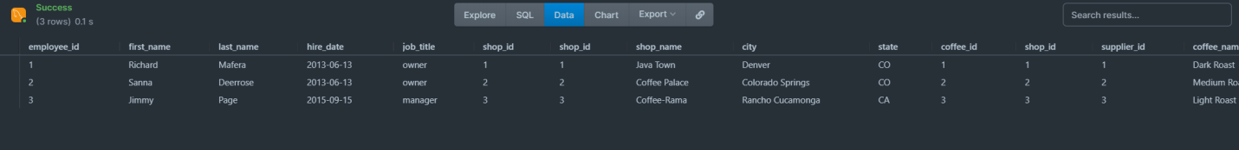

Note: The result is slightly too large to fit in the image. “price_per_pound” is still listed after “coffee_name.”